Project Report: Pipelined vs Non-Pipelined CPU Simulator

1. Introduction
This project implements a comprehensive CPU instruction execution simulator that comparespipelinedandnon-pipelinedCPU architectures. The system consists of two components:
- GUI Application(C++/Win32) for visual simulation and comparison
- CLI Application(Assembly/emu8086) for command-line demonstration
The simulator allows users to input a sequence of simplified assembly-like instructions (ADD, SUB, LOAD, STORE, MUL, JMP) and calculates the number of clock cycles required under both execution models.

2. CPU Architecture Concepts

2.1 Non-Pipelined CPU
Anon-pipelined(or sequential) CPU executes instructions one at a time, completing all stages of an instruction before starting the next.
Characteristics:
- Simple design and implementation
- No instruction overlap
- Poor resource utilization
- Predictable but slow execution
Execution Pattern:
Instruction 1: [IF][ID][EX][MEM][WB]
Instruction 2: [IF][ID][EX][MEM][WB]
Instruction 3: [IF][ID][EX][MEM][WB]

2.2 Pipelined CPU
ApipelinedCPU overlaps instruction execution by dividing the instruction cycle into independent stages, allowing multiple instructions to be processed simultaneously.
Characteristics:
- Complex design with hazard detection
- High throughput (1 instruction/cycle in steady state)
- Better resource utilization
- Potential for pipeline hazards
5-Stage Pipeline:
Cycle 1: I1[IF]
Cycle 2: I1[ID] | I2[IF]
Cycle 3: I1[EX] | I2[ID] | I3[IF]
Cycle 4: I1[MEM] | I2[EX] | I3[ID] | I4[IF]
Cycle 5: I1[WB] | I2[MEM] | I3[EX] | I4[ID] | I5[IF]

2.3 Pipeline Stages
- IF (Instruction Fetch): Fetch next instruction from memory
- ID (Instruction Decode): Decode instruction and read registers
- EX (Execute): Perform ALU operation or address calculation
- MEM (Memory Access): Read/write data memory
- WB (Write Back): Write result to register file

3. Mathematical Formulas

3.1 Non-Pipelined Cycles Calculation
Non-Pipelined Cycles = (Number of Instructions) × (Number of Stages)
Example:5 instructions × 5 stages = 25 cycles

3.2 Pipelined Cycles Calculation
Pipelined Cycles = (Number of Stages) + (Number of Instructions - 1)
Example:5 stages + (5 instructions - 1) = 9 cycles

3.3 Speedup Calculation
Speedup = Non-Pipelined Cycles ÷ Pipelined Cycles
Example:25 ÷ 9 = 2.78x faster

3.4 Efficiency Metrics
- Throughput: Instructions per cycle (IPC)
- CPI: Cycles Per Instruction
- Efficiency Gain: Percentage improvement

4. GUI Application (C++/Win32)

4.1 Development Environment
- IDE: Eclipse CDT with MinGW/GCC
- Language: C++ with Win32 API
- Platform: Windows
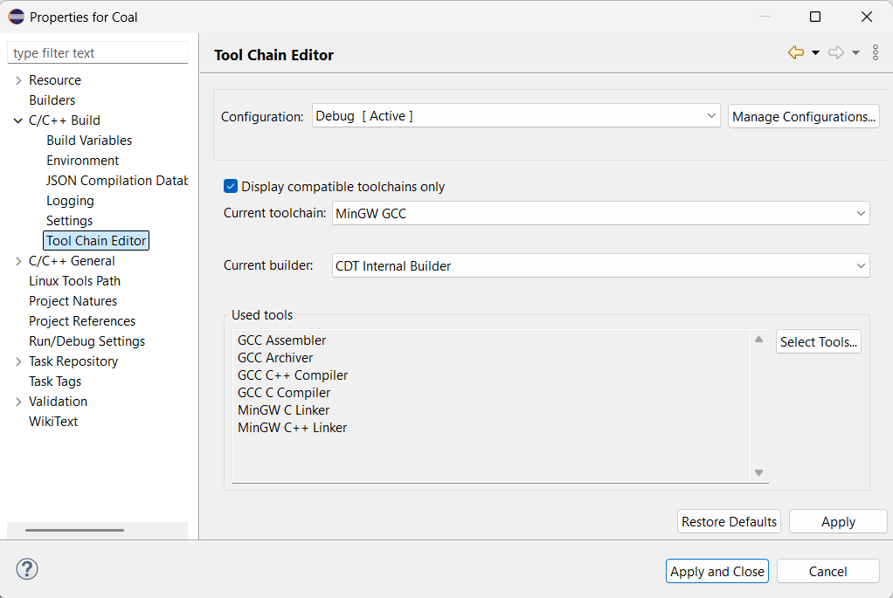

4.2 Key Features
- Instruction Input: Support for 6 instruction types with validation
- Visual Simulation: Graphical representation of execution patterns
- Performance Comparison: Side-by-side cycle comparison
- Color-coded Interface: Professional UI with color scheme
- Detailed Analysis: Stage-by-stage breakdown

4.3 Workflow
1. User enters instruction (ADD/SUB/LOAD/STORE/MUL/JMP)
2. Click "Add" to add to instruction sequence
3. Instruction appears in the list
4. Click simulation buttons:
- "Non-Pipeline": Shows sequential execution analysis
- "Pipeline": Shows parallel execution with timeline
- "Compare": Shows performance comparison
- "Stages Info": Shows pipeline stage details
- Results display cycle counts, speedup, and efficiency
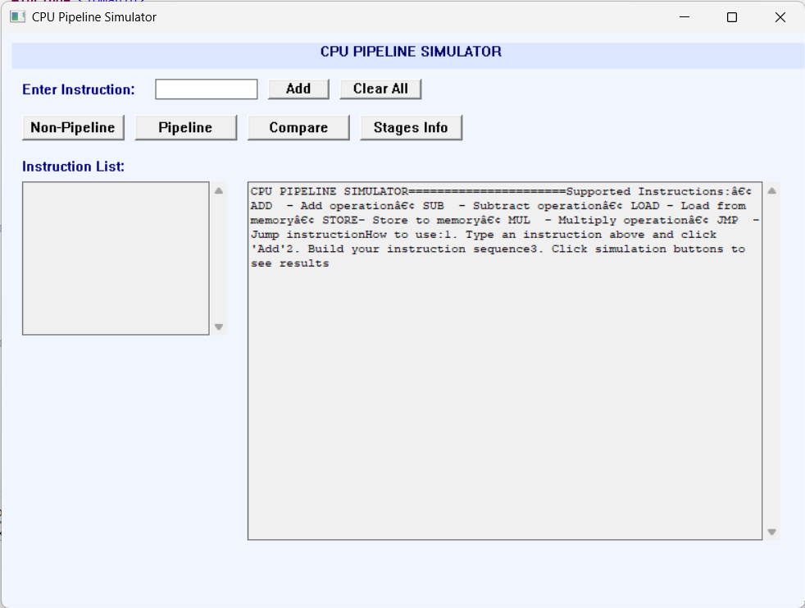
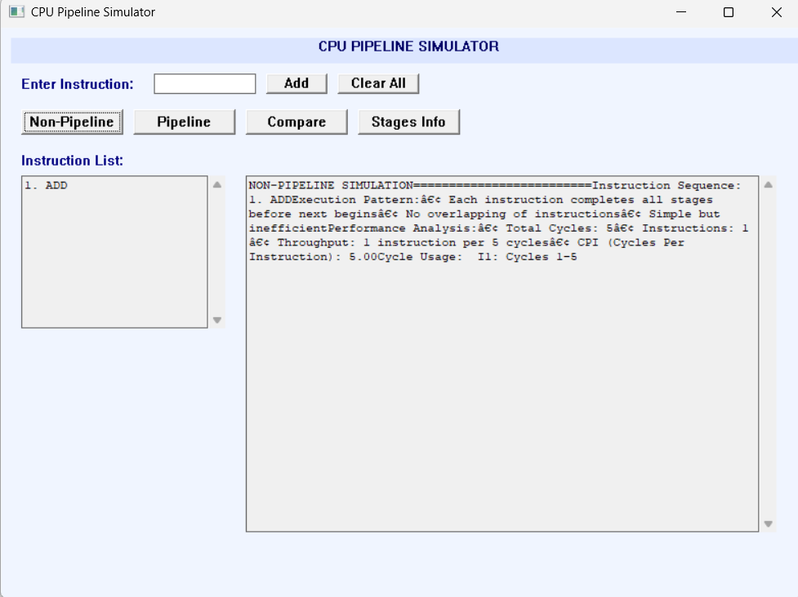

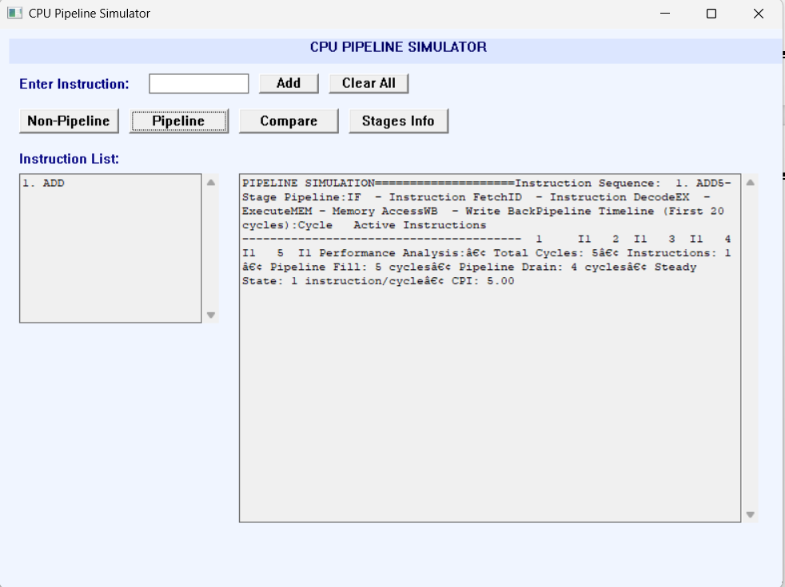

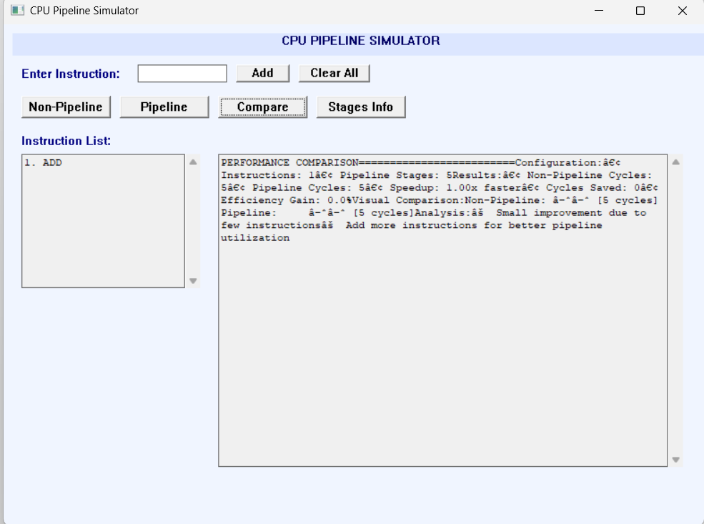

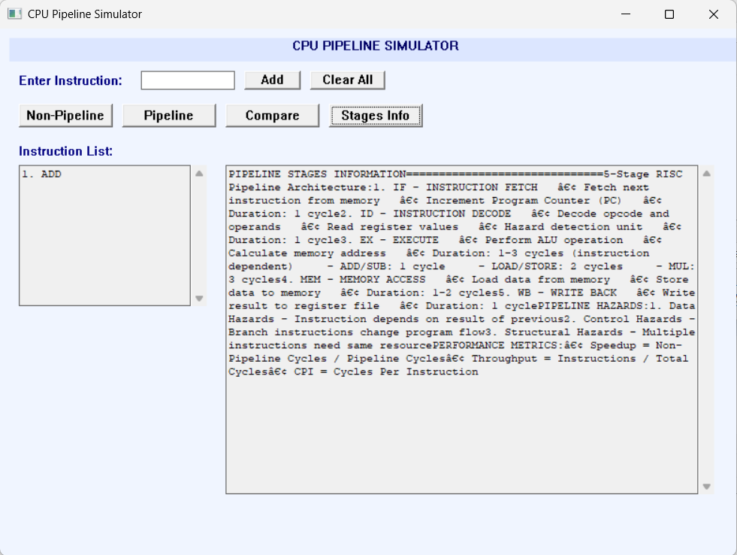

4.4 Class Structure
class PipelineSimulator {
private:
vector<string> instructions;
vector<Instruction> instrList;
int pipelineStages;
public:
// Core methods
void addInstruction(string instr);
int getNonPipelinedCycles();
int getPipelinedCycles();
float getSpeedup();
};

4.5 Color Scheme
- Background: Light blue (RGB 240, 245, 255)
- Text Areas: Ivory (RGB 255, 255, 240)
- Buttons: Steel blue (RGB 70, 130, 180)
- Lists: Light yellow (RGB 255, 250, 240)
- Titles: Dark blue (RGB 0, 0, 100)
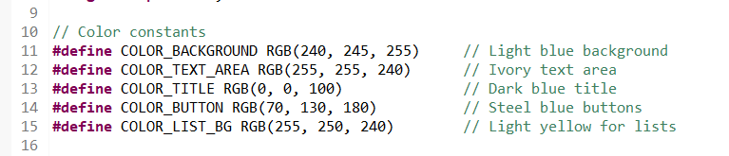

5. CLI Application (Assembly/emu8086)

5.1 Development Environment
- Emulator: emu8086
- Language: x86 Assembly (16-bit)

5.2 Key Features
- Simple Interface: Command-line input/output
- Cycle Calculation: Basic pipeline vs non-pipeline comparison
- Instruction Validation: Checks for valid instructions
- Result Display: Clear formatting of results
- Educational: Demonstrates assembly programming concepts

5.3 Workflow
1. Program displays title and instructions
2. User enters instructions one by one
3. Type "END" to finish input
4. Program calculates:
- Non-pipelined cycles
- Pipelined cycles
- Speedup factor
- Cycles saved
5. Displays detailed analysis and pipeline information
6. Waits for key press before exiting
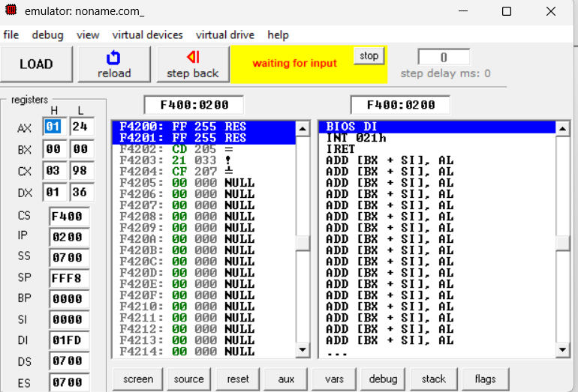

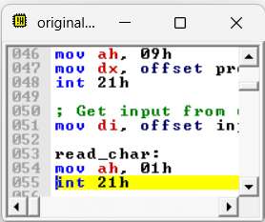

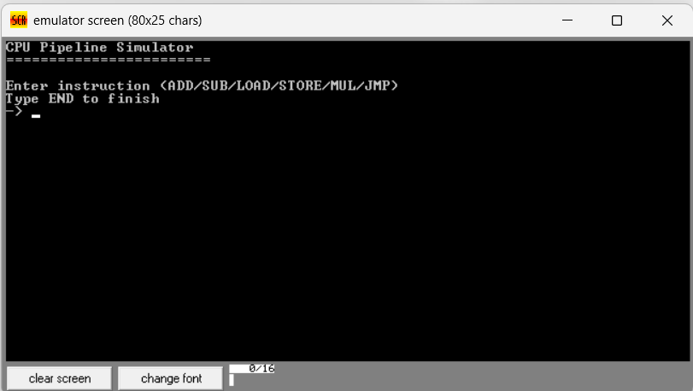

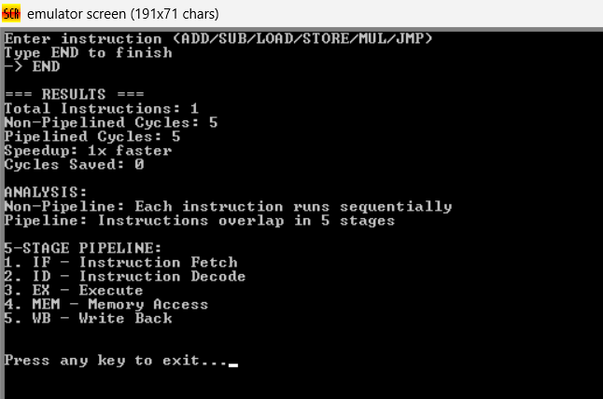

5.4 Assembly Implementation Details
; Key variables
inst_count DB 0 ; Instruction counter
np_cycles DW 0 ; Non-pipelined cycles
p_cycles DW 0 ; Pipelined cycles
; Main calculation functions
calculate_np: ; inst_count × 5
calculate_p: ; 5 +$(inst_{c}ount−1)calc$ulate_speedup: ; np_cycles ÷ p_cycles

6. Comparison of Both Implementations
Aspect | GUI Application | CLI Application
Language | C++ with Win32 API | x86 Assembly
Platform | Windows with GUI | DOS/emu8086
Input Method | Graphical input boxes | Command-line text
Output Format | Rich text with colors | Plain text
Visualization | Graphical timeline | Text-based analysis
Complexity | High (OOP, GUI) | Low (procedural)
Educational Value | Demonstrates modern GUI programming | Demonstrates low-level CPU concepts

7. Instruction Types and Timing
Instruction | Stages | Duration | Description
ADD/SUB | 5 | 1 cycle/stage | Arithmetic operations
LOAD/STORE | 5 | 2 cycles/stage | Memory access operations
MUL | 5 | 3 cycles/stage | Multiplication operation
JMP | 3 | 1 cycle/stage | Branch instruction

8. Results and Analysis Example

Sample Input:
ADD, SUB, LOAD, STORE

Calculations:
Non-Pipelined: 4 × 5 = 20 cycles
Pipelined: 5 + (4-1) = 8 cycles
Speedup: 20 ÷ 8 = 2.5x faster
Cycles Saved: 20 - 8 = 12 cycles
Efficiency Gain: (12 ÷ 20) × 100 = 60%

Visual Timeline (Pipeline):
Cycle 1: I1[IF]
Cycle 2: I1[ID] | I2[IF]
Cycle 3: I1[EX] | I2[ID] | I3[IF]
Cycle 4: I1[MEM] | I2[EX] | I3[ID] | I4[IF]
Cycle 5: I1[WB] | I2[MEM] | I3[EX] | I4[ID]
Cycle 6: I2[WB] | I3[MEM] | I4[EX]
Cycle 7: I3[WB] | I4[MEM]
Cycle 8: I4[WB]

